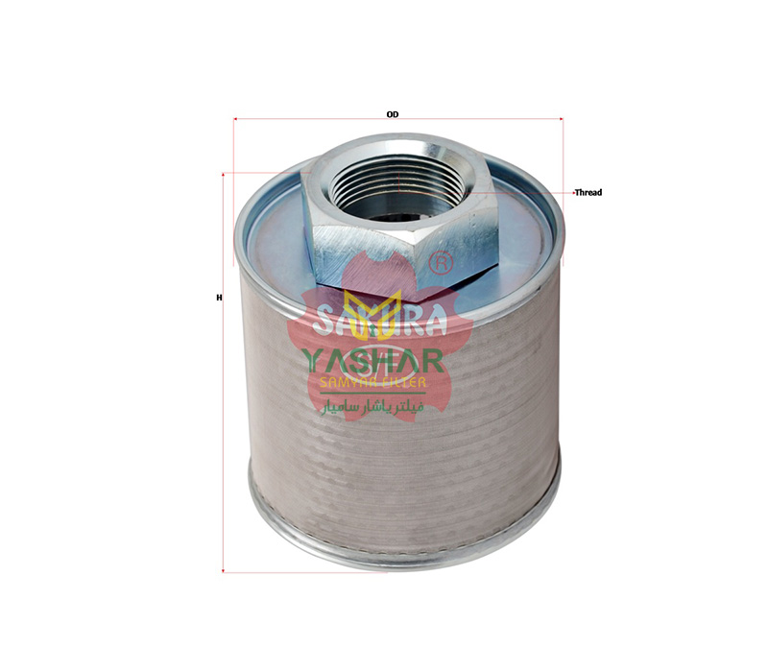

|  |  |
| --- | --- |
| **Specification** | Filter : **H-8526 Sakura** |
| **Model** | Element |
| **H1 ( Height )** | 116 mm |
| **H2 ( Height )** | 98 mm |
| **Outer Diameter 1** | 99 mm |
| **Outer Diameter 2** | 99 mm |
| **Filter Type** | Hydraulic Oil Filter |
| **Volume (m3)** | 0.041 |

